## **Objective:** To gain business insights and understand customer and product trends through SQL queries.

### **Dataset Description:** A dataset called sales_data containing the following columns:

* OrderID (unique identifier for each order)
* CustomerID (ID of the customer who placed the order)
* ProductID (ID of the product sold)
* OrderDate (date of the sale)
* Quantity (number of products sold in each order)
* UnitPrice (price per unit of the product)
* Region (region where the sale was made)
* Category (category of the product)

#### **SAMPLE DATASET:**

INSERT INTO sales_data (OrderID, CustomerID, ProductID, OrderDate, Quantity, UnitPrice, Region, Category)

VALUES

(1, 101, 201, '2024-01-05', 5, 20.00, 'North', 'Electronics'),

(2, 102, 202, '2024-01-10', 2, 35.00, 'South', 'Home Appliances'),

(3, 103, 203, '2024-02-15', 1, 120.00, 'East', 'Furniture'),

(4, 104, 201, '2024-02-20', 10, 20.00, 'West', 'Electronics'),

(5, 105, 204, '2024-03-01', 7, 50.00, 'North', 'Clothing'),

(6, 106, 205, '2024-03-15', 4, 80.00, 'South', 'Footwear'),

(7, 107, 206, '2024-04-05', 3, 100.00, 'East', 'Electronics'),

(8, 108, 203, '2024-04-15', 2, 120.00, 'West', 'Furniture'),

(9, 109, 204, '2024-05-05', 1, 50.00, 'North', 'Clothing'),

(10, 110, 202, '2024-05-10', 8, 35.00, 'South', 'Home Appliances'),

(11, 111, 207, '2024-06-05', 5, 25.00, 'East', 'Stationery'),

(12, 112, 201, '2024-06-15', 6, 20.00, 'West', 'Electronics'),

(13, 113, 208, '2024-07-05', 4, 15.00, 'North', 'Toys'),

(14, 114, 206, '2024-07-10', 1, 100.00, 'South', 'Electronics'),

(15, 115, 209, '2024-08-01', 3, 30.00, 'East', 'Books'),

(16, 116, 210, '2024-08-15', 7, 45.00, 'West', 'Groceries'),

(17, 117, 211, '2024-09-01', 2, 200.00, 'North', 'Jewelry'),

(18, 118, 212, '2024-09-10', 5, 18.00, 'South', 'Accessories'),

(19, 119, 202, '2024-10-01', 4, 35.00, 'East', 'Home Appliances'),

(20, 120, 201, '2024-10-15', 9, 20.00, 'West', 'Electronics');

**Questions:**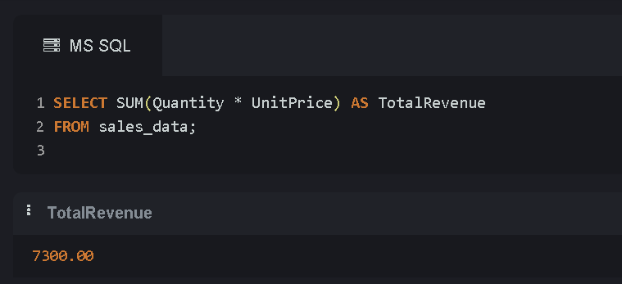

**Total Sales Revenue**Find the total revenue generated across all sales.

**Top 5**

**Best-Selling Products**Identify the top 5 products based on the quantity sold.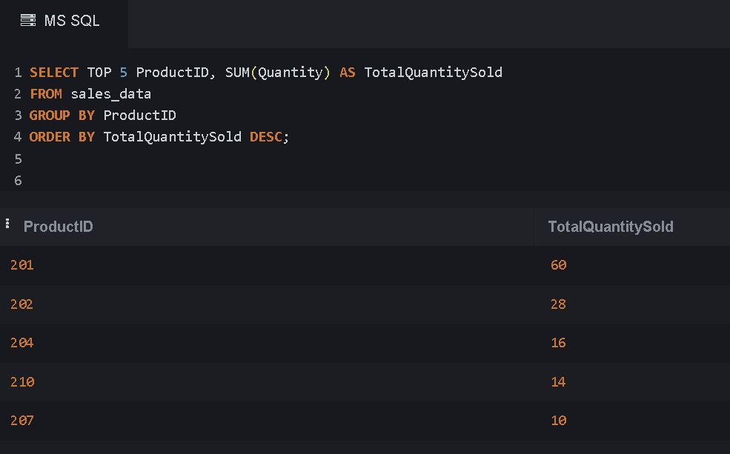

**Monthly Sales Trend**Calculate the monthly revenue for each month to identify sales trends.  
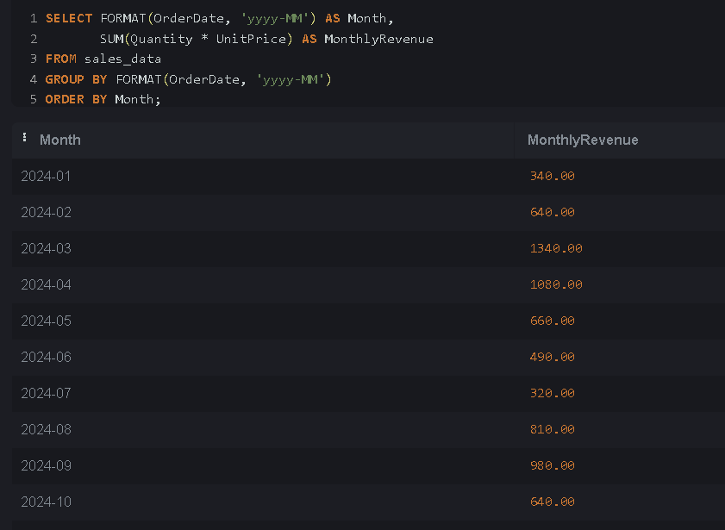

**Regional Sales Breakdown**Analyze sales revenue for each region to determine where the highest sales are occurring.  
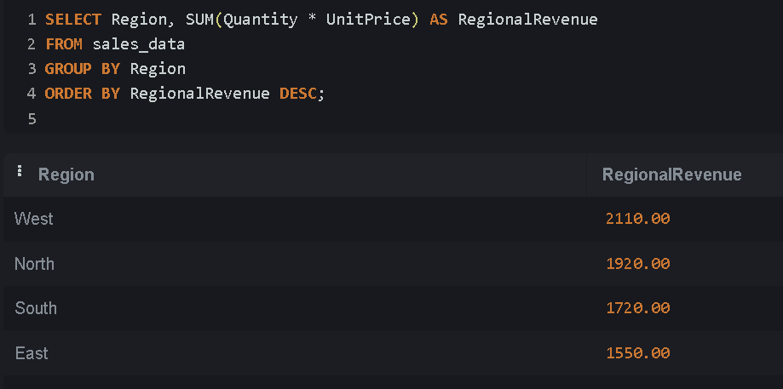

#### **Most Popular Product Category** Determine which product category has the highest total sales in revenue.

